Using the Temperature and Humidity Sensor

Scratch Version

March 12, 2017

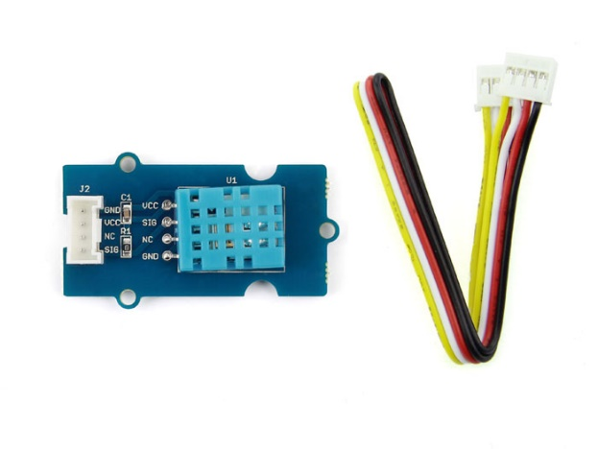

# Overview

The Temperature and Humidity Sensor reports the current temperature in Celsius and relative humidity.

# Setting up

Power up your Raspberry Pi/GrovePi and start up Scratch. If you haven’t done this before, work through the “Getting started with Grove Sensors” document. Your screen should look like this:

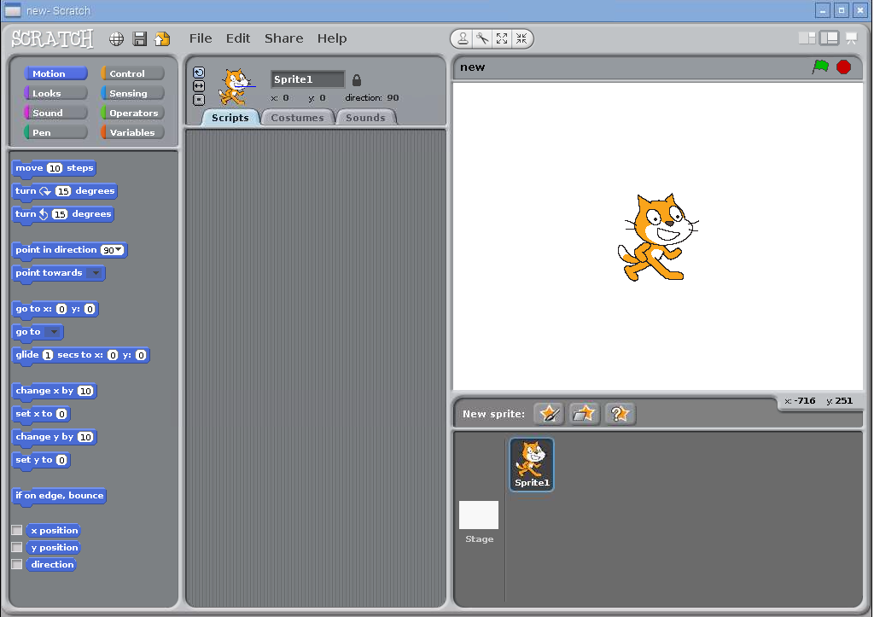

Now, find the Temperature and Humidity Sensor and cable in the kit. Connect the sensor to any of the digital ports on the Grove Pi. In this example, we connected it to port D7. If you connect it to a different port, be sure to replace the number 7 in the scripts below with the number of your port.

# Reading the temperature

You must ask the Temperature and Humidity sensor for the current temperature. It won’t report it on its own. The way to do this is to broadcast a message with the word “temp” and the pin number to it. Try it out by placing a “broadcast” block:

Screen Clipping

Click on the black triangle to change the message and type in “temp7”:

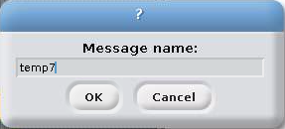

Click OK. The next step is to add a sensor block to your script that reads the temperature. Go to “Sensing” and add the “slider sensor value” block at the bottom. Once you add it, you should be able to click on the black triangle to change what is being sensed. But there’s a problem! Here’s what you should see:

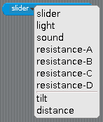

The temperature isn’t listed! To fix this, double click on the “broadcast temp7” block. Click on the sensor value block again and you should see:

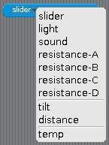

Select “temp” so that your sensor value block looks like this:

Screen Clipping

Now it’s time to see what the temperature is. Try building this script:

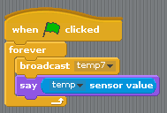

Run it and watch Scratch Cat tell you what the temperature is in degrees Celsius. Place your hands over the sensor to see if you can warm it up.

# Reading the Humidity

Reading the humidity is like reading the temperature. Create a broadcast block except use the word “humidity”. Here’s an example:

Screen Clipping

Just like the “sensor value” block didn’t know about temperature until you clicked on the broadcast block, it also doesn’t know about humidity. Click on the “broadcast humidity7” block to tell Scratch about the humidity sensor.

Change your program that reported temperature to report humidity:

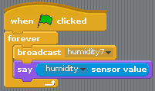

# Common problems

## The sensors report the word “nan” instead of a number

This happens sometimes. I think that it is a bug with the Grove Pi. If this causes problems with your program, try adding an “if” statement to skip using the sensor value if it reads “nan”.

For the curious, “nan” is short for “Not a Number”. Computers report “nan” when they get something that doesn’t make sense in a calculation.

## How do I get the temperature in Fahrenheit?

The conversion from Celsius to Fahrenheit is:

$$F=32+\frac{9}{5}C$$

For example, temperature program would look like this:

